Composing an Abstract of the Poster Presentation for the Annual Meeting of the Microscopy Society of Taiwan

Wei-Chih Li (李威志), ^{1*} and Shen-Chuan Lo (羅聖全)²
¹ Department of Materials Science and Engineering, National Taiwan University, Taipei, Taiwan
² Material and Chemical Research Laboratories, Industrial Technology Research Institute, Hsinchu, Taiwan
*weichihli@ntu.edu.tw
This document gives the formatting instructions for authors to prepare the abstract. The abstract, including the text, figures and tables, is limited within one page. The page size is A4; all margins must be set as 2.54 cm (1 inch). The font style used for the entire abstract should be Times New Roman - the title is in 14 point bold font, and the text is in 12 point regular font. Figures are numbered using Arabic numerals, followed by captions, as shown in Fig. 1. Tables are immediately following their title.

References are in the style as shown below [1, 2].

Abstract submission is due by Aug 31, 2019.

References
- R. W. K. Honeycombe, Metall. Trans. A, 7 915 (1976).
- D. B. Williams and C. B. Carter, Transmission Elecron Microscopy: A Textbook for Materials Science. Springer, New York (2009).

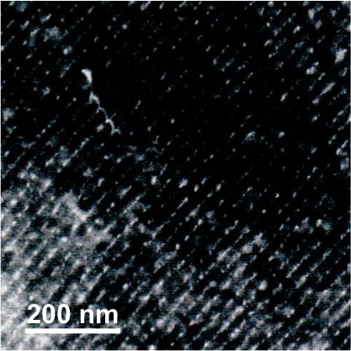

Figure 1. Sample figure for the abstract. The figure caption is in 12 point regular font.

